Capstone Project Pre-Submission Document

Predicting Hospital Readmissions for MediCare Health Network

Contributors
- Gundeep Singh Saund
- Keshava B R
- Anuja Amol Paritkar
- Jayanth Thyagarajan

Business Problem Understanding and Objective Formulation
This project focuses on Healthcare Operations and Quality Management, specifically reducing 30-day hospital readmissions—a key indicator of the quality of inpatient care, discharge planning, and post-discharge support. MediCare Health Network has observed increasing readmission rates despite investments in Electronic Health Records (EHRs) and improved healthcare services. High readmission rates increase treatment costs, reduce bed availability, lower patient satisfaction, and may lead to financial penalties.
The available dataset combines patient demographics, medical history, laboratory results, medications, hospitalization details, discharge information, and administrative records. Since the data indicates that approximately 34% of patients were readmitted, appropriate techniques will be required to address the moderately imbalanced target class during model development.
Business Objective: Develop a machine learning solution to identify patients at high risk of readmission before discharge, enabling timely interventions such as personalized discharge planning, medication counselling, and follow-up care to improve patient outcomes and optimize healthcare resources.
Analytical Objectives
- Identify the key factors influencing hospital readmissions.
- Build and evaluate a predictive classification model for readmission risk.
- Determine the most important features contributing to predictions.
- Provide actionable insights to support clinical decision-making and reduce avoidable readmissions.

Challenges and Constraints
Predicting hospital readmissions involves several challenges and constraints across data, clinical, machine learning, and operational dimensions. Healthcare datasets often contain missing values, inconsistent entries, duplicates, and legacy attributes with unclear meaning, requiring extensive cleaning and contextual interpretation. Data heterogeneity, high-cardinality fields, and class imbalance further complicate modelling, as accuracy alone may be misleading.
Clinically, recovery outcomes vary even for similar diagnoses, chronic disease progression is unpredictable, and factors like medication adherence or social determinants are not fully captured.
From a machine learning perspective, risks include overfitting, correlated features, and the need to balance precision and recall while maintaining interpretability for clinician trust. Operationally, privacy compliance, limited temporal granularity, and integration with hospital systems pose constraints.
Finally, adoption depends on explainability and alignment with workflows, as stakeholders may prefer slightly less accurate but transparent models that support trust, scalability, and real-world implementation.

Background Study / Literature Review
Hospital readmission prediction has been extensively studied using both statistical and machine learning approaches. Traditional indices such as the LACE index and the PARR index are widely adopted in healthcare systems due to their simplicity and interpretability. However, multiple evaluations show that their predictive performance is modest. These models are useful for baseline risk stratification but often fail to capture the complex, non-linear interactions among clinical, demographic, and behavioural factors.
Traditional models such as logistic regression remain popular for their interpretability and suitability for binary classification, but recent studies demonstrate that machine learning methods—particularly decision trees, random forests (RF), gradient boosting, XGBoost, support vector machines (SVM), and artificial neural networks (ANN)—achieve superior predictive performance. Tree-based models and neural networks are frequently cited as most effective, as they capture complex non-linear relationships, perform feature selection, and converge faster to improved accuracy.
Readmission risk is influenced by diverse factors including age, chronic disease burden, prior admissions, discharge condition, medication adherence, laboratory abnormalities, and compliance with follow-up care. Literature emphasizes that predictive modelling must be embedded in a structured workflow: preprocessing, exploratory analysis, class imbalance handling, model evaluation, and feature interpretation. Crucially, prediction systems must support actionable care pathways—such as discharge education, home monitoring, and medication review—ensuring both accuracy and clinical usefulness.
Therefore, while LACE and PARR remain industry benchmarks, our ML approach not only improves prediction accuracy but also enhances decision usefulness by supporting actionable care pathways.
Proposed Methodology / Solution Approach 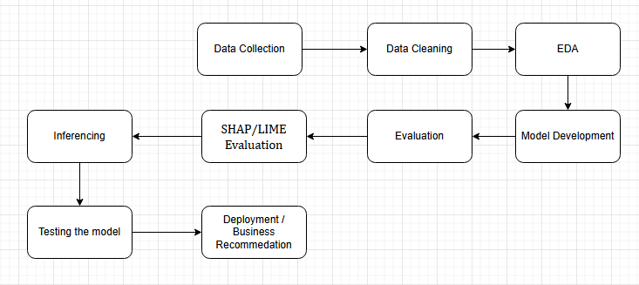
- Data Collection → Gather patient demographics, clinical records, and hospitalization history.
- Data Cleaning → Remove duplicates, handle missing values, and standardize medical variables, outlier analysis.
- EDA (Exploratory Data Analysis) → Identify patterns, correlations, and risk factors influencing readmission.
- Model Development → Build predictive models using machine learning algorithms on patient data.
- Evaluation → Assess model accuracy, precision, recall, F1 score and overall predictive performance.
- SHAP/LIME Evaluation → Interpret model predictions to highlight key clinical drivers of readmission.
- Inferencing → Generate patient-level readmission risk scores from the trained model.
- Testing the Model → Validate robustness across unseen patient cohorts and edge cases.
- Deployment / Business Recommendation → Integrate into hospital workflows and recommend actionable interventions.

Proposed Timeline
Week 1 | Business understanding, data collection, literature review
Week 2 | Data cleaning, preprocessing, feature engineering
Week 3 | Exploratory Data Analysis and visualization
Week 4 | Baseline model development
Week 5 | Advanced model building and hyperparameter tuning
Week 6 | Model evaluation, explainability
Week 7 | Inferencing, testing the outcome
Week 8 | Deployment & Business Recommendations

Expected Deliverables / Outputs
The expected outputs of the project are as follows:
- Business Problem Understanding Report summarizing the readmission challenge and project objectives.
- Data Analysis Report covering preprocessing steps, exploratory findings, and feature-level observations.
- Predictive Machine Learning Model(s) for hospital readmission classification.
- Model Evaluation Report comparing baseline and advanced models using appropriate performance metrics.
- Risk Factor Interpretation identifying the variables most strongly associated with readmission.
- Dashboard / Visualizations presenting important trends, model outputs, and patient risk insights.
- Business Recommendations suggesting targeted interventions for high-risk patient groups.
- Technical Documentation / Deployment Proposal outlining how the model can be integrated into hospital decision workflows.

